MOUNTING THE EFJ/ KENWOOD VM-600 MOBILE WITH UNUSUAL BOLT HOLE PATTERN
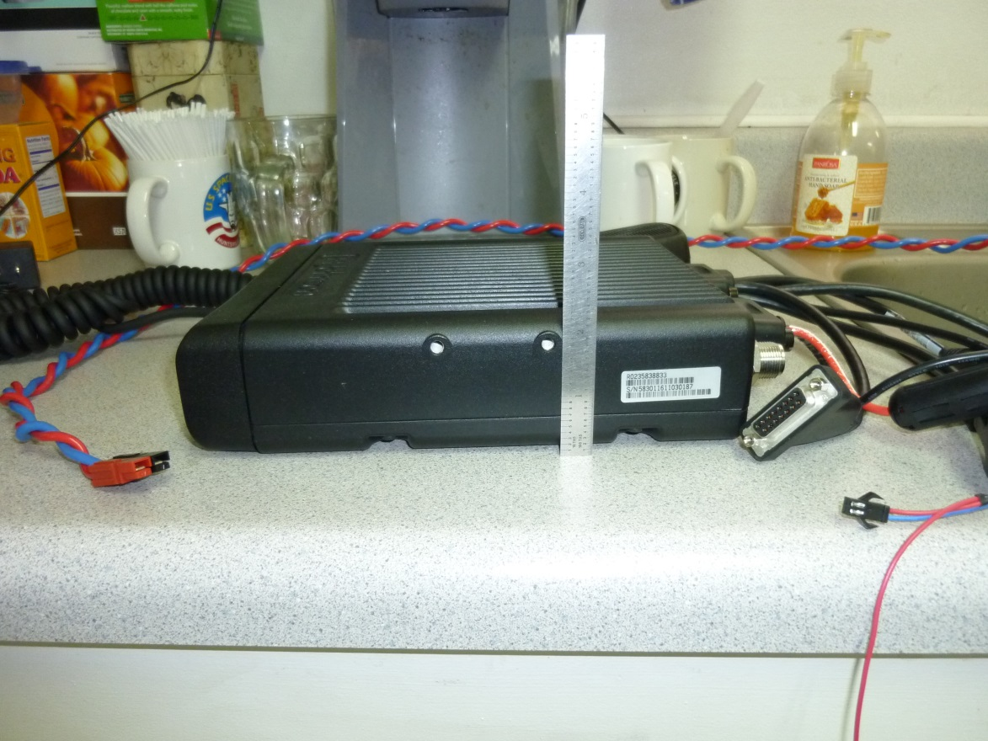
MAKE BRACKETS 2.75” TALL TO THE BEND; PUNCH OBROUND 1/4” BELOW THE TOP FOR A 2U TRAY
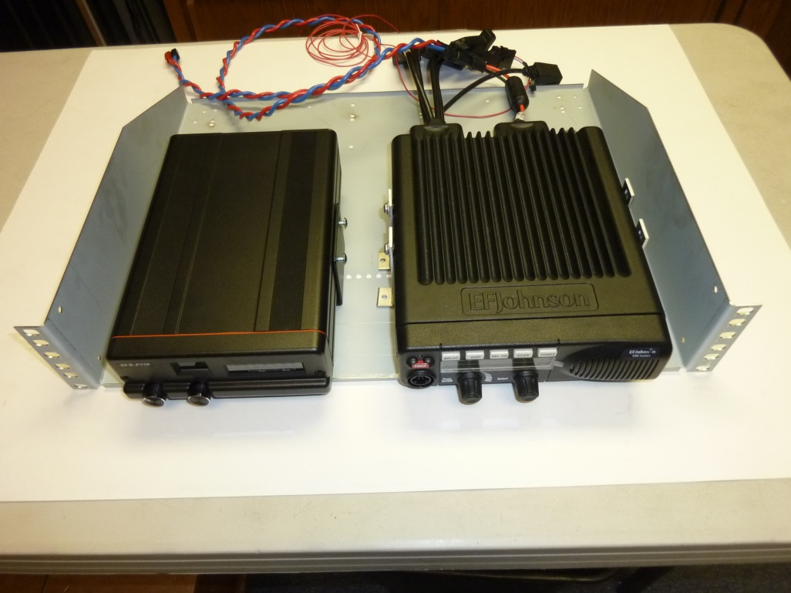
SUPPLY 4 EACH 10/32 BOLTS & WASHERS FOR MOUNTING BRACKET TO THE RADIO

